Jenkins Challenge-02

Create a Declarative Jenkins parameterized pipeline for simplecustomerapp.
Requirements:
- Create a Pipeline job in Jenkins.
- Use a Git repository for simplecustomerapp.
- Add parameters:
• BRANCH_NAME (string, default: main)
• ENV (choice: dev, qa)
- Define environment variables:
• APP_NAME = simplecustomerapp
- Implement stages:
• Checkout (based on BRANCH_NAME)
• Build (mvn clean compile)
• Test (mvn test)
• Package (mvn package)
- Add post actions:
• Success → print success message with environment
• Failure → print failure message
- Trigger using Build with Parameters.
 Outcome
• Parameterized Jenkins pipeline created
• Code is built, tested, and packaged automatically
• JAR file generated in target/
• Clear visibility of build stages and logs
• Single pipeline works for multiple environments
 Advantages
• One pipeline can be reused for different branches and environments
• Reduces manual build and deployment effort
• Early test failures stop bad code from moving forward
• Easy to maintain and extend (SonarQube, Docker, Deploy stages later)

Step by step Implementation:

Step 1: Navigate to ec2 in aws and launch a instance.
- Instance type is t2-xlarge to have a large memory.
- New key pair added.

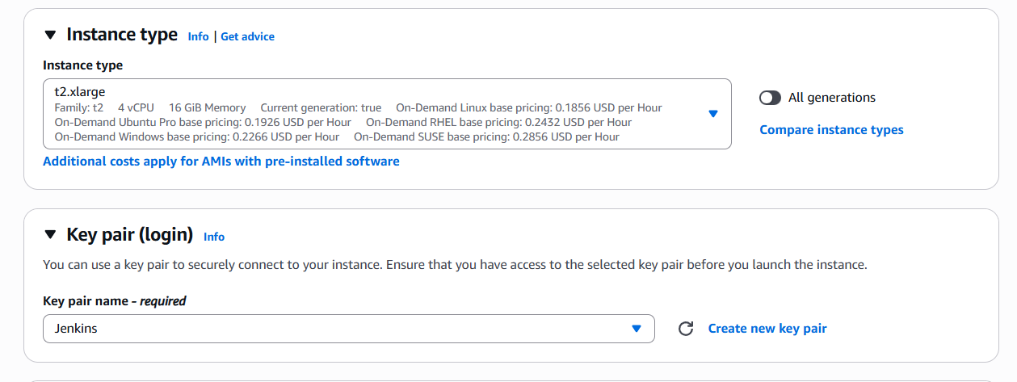

- VPC is default and existing security groups updated as well.
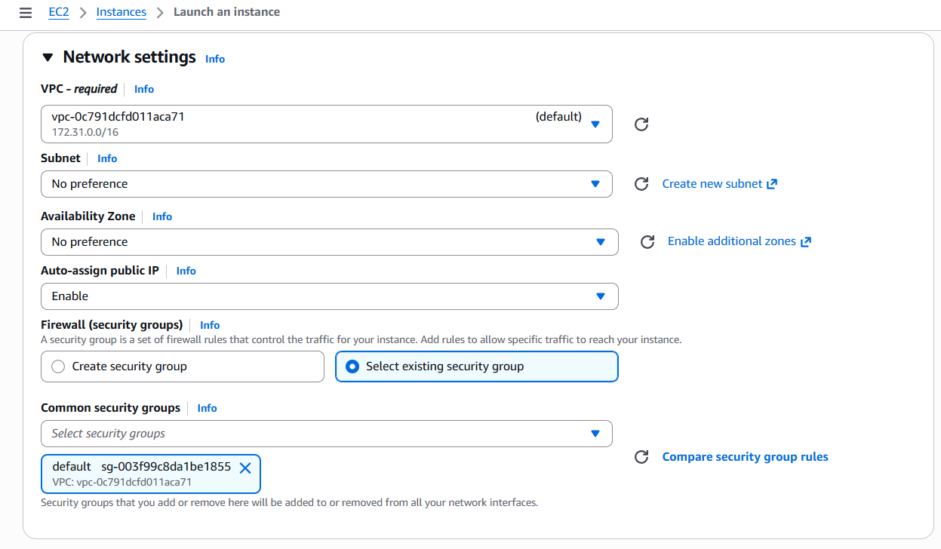

- I have updated my EBS as 20 GB for my storage.
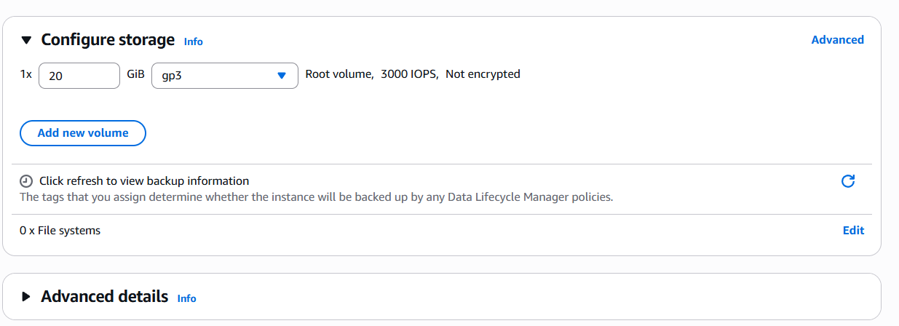

- Instance launched successfully.
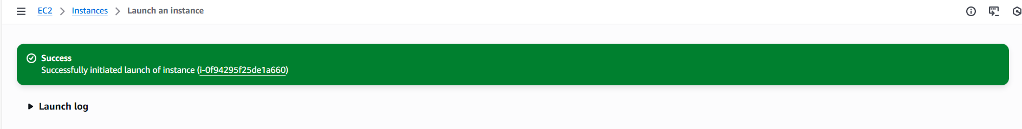

Step 2: Let’s connect to cli through Public ip and install java-17 version.
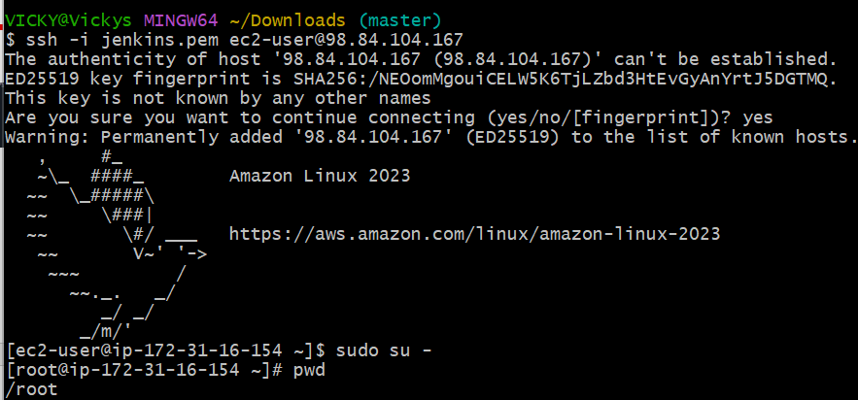

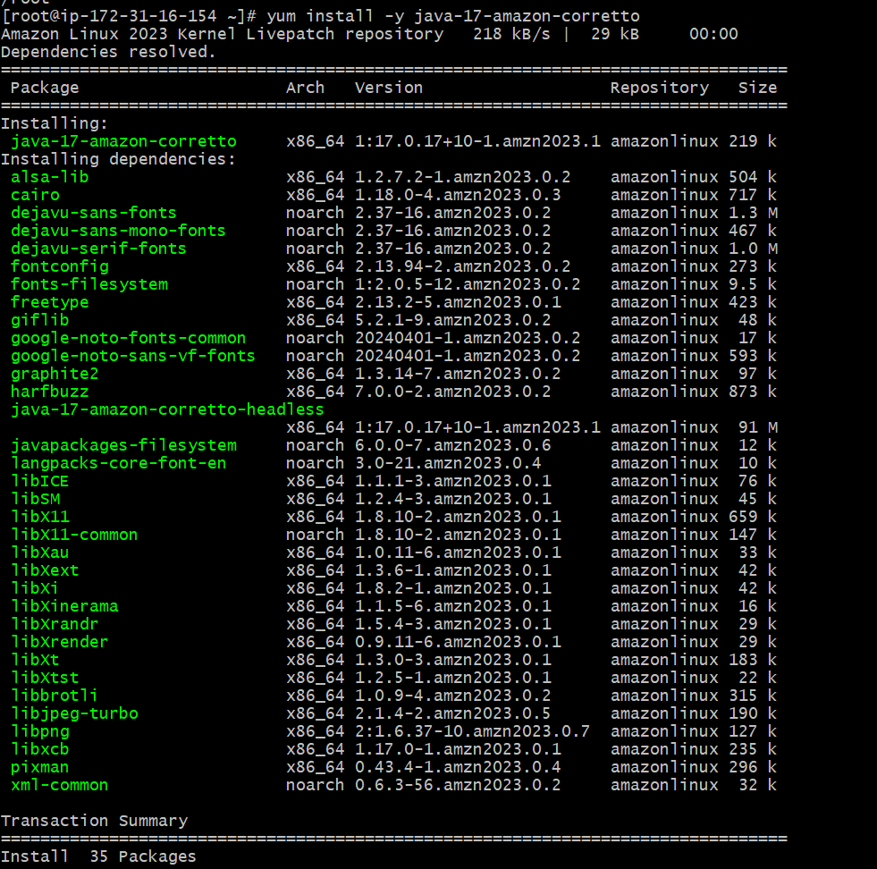
Step 3: Install the Jenkins package and rpm keys. Use the command below.
sudo wget -O /etc/yum.repos.d/jenkins.repo https://pkg.jenkins.io/redhat-stable/jenkins.repo
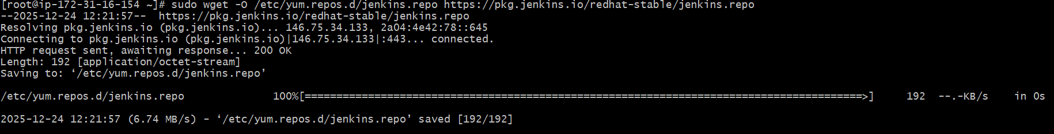

Step 4: Installation of Jenkins package and rpm keys are done and we need to import keys. Use command below.
sudo rpm --import https://pkg.jenkins.io/redhat-stable/jenkins.io-2023.key
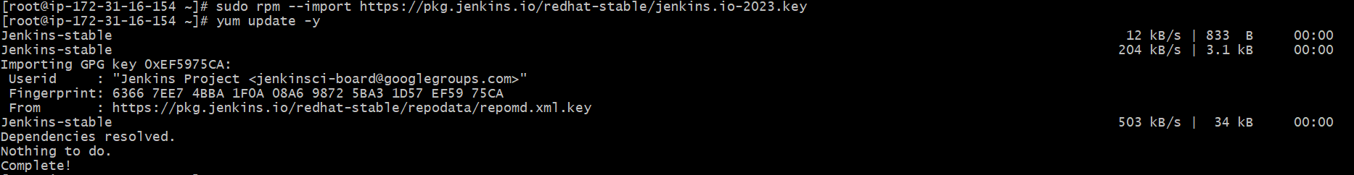

Step 5: Now, we shall proceed with installing Jenkins
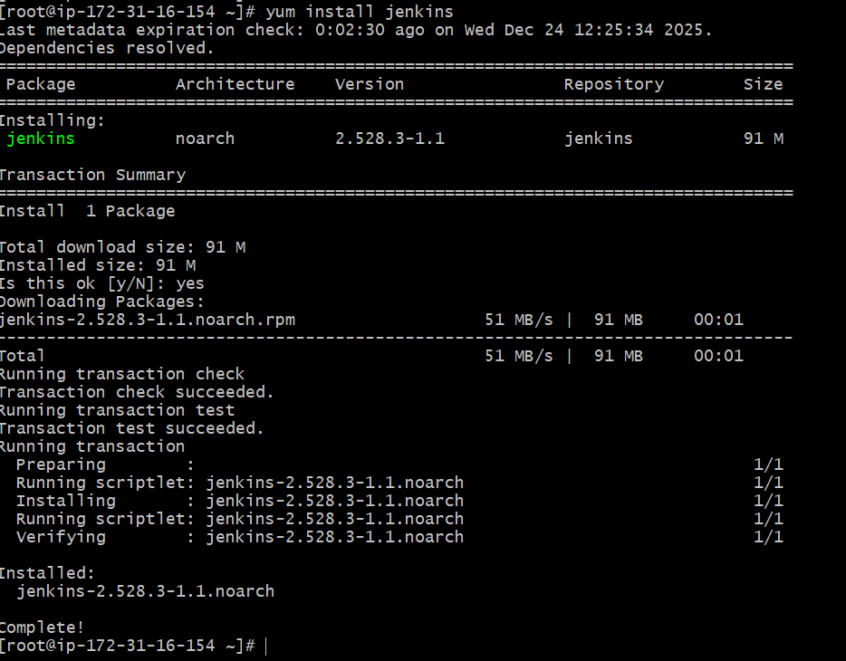
Step 6: Installation is successful. We shall start and enable the package.
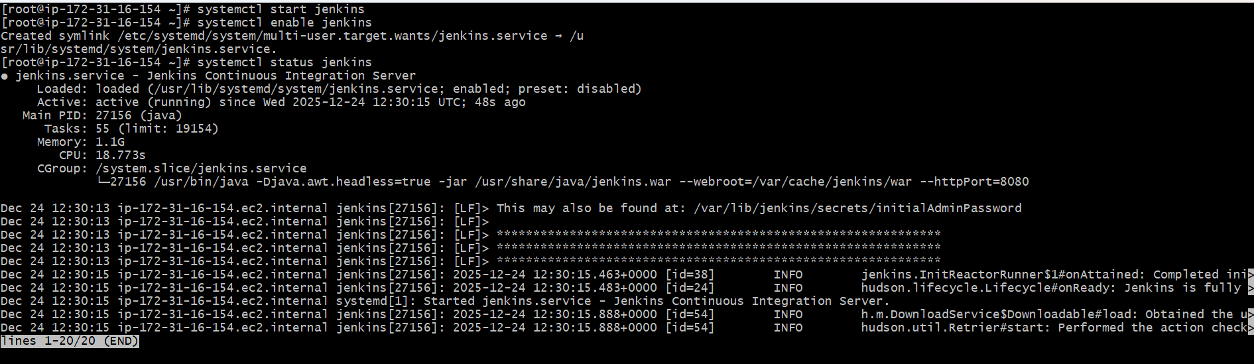

Success- Now Jenkins is active and shall verify if the port is working as excepted.
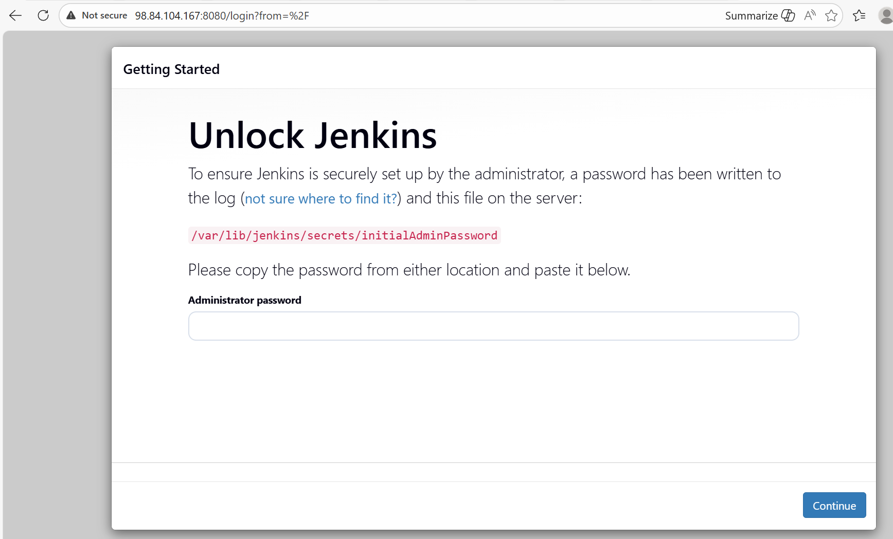

Step 7: Deployment location of Jenkins is /var/lib/Jenkins
We require the password to login into Jenkins, so we need to change directory to Secrets and cat the initial password and we’ll be able to login.

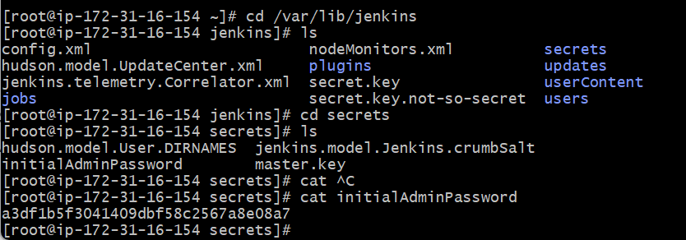
- Password updated and logged in successfully.
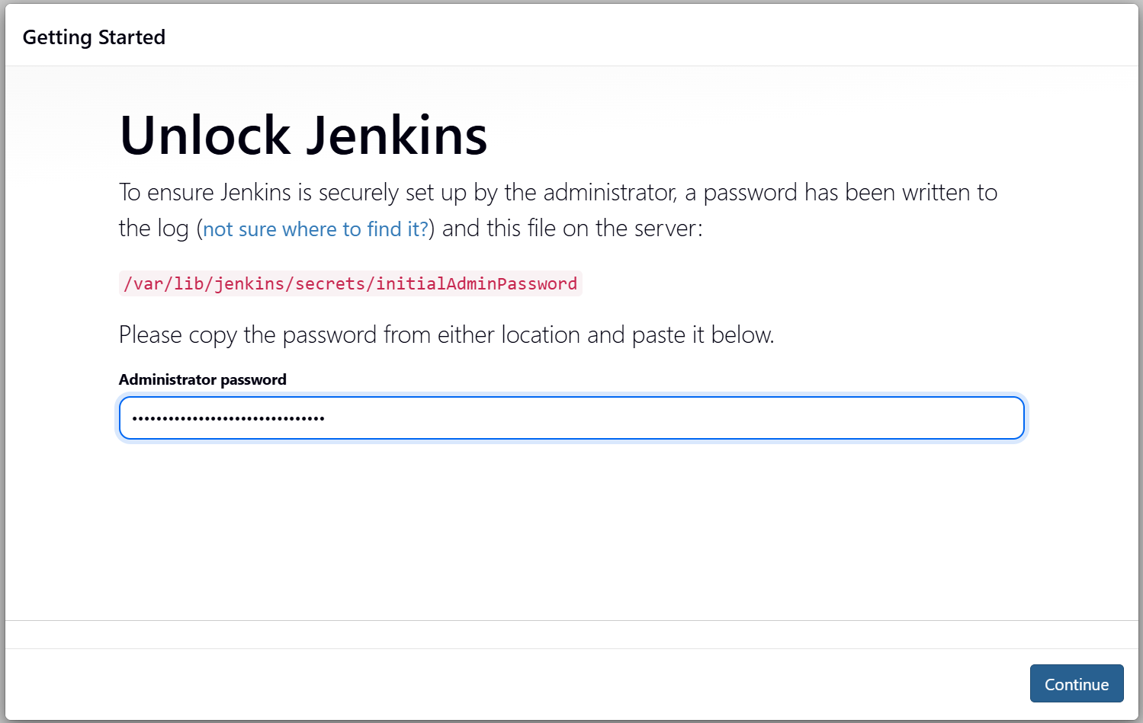
Step 8: Now, this is the last part of this task- to change the port number and verify if 8080 to 8081 port number works on browser?
Default location of file is /usr/lib/systemd/system/Jenkins.service
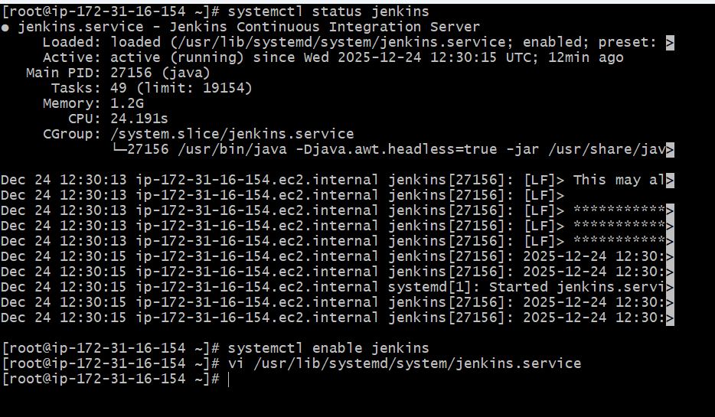

Now, its time to secure the initial password, so follow the below steps.
Step 9: This is the 1st step once connected to port 8080 in website. Click on suggested plugins and continue.
- Create a username password provide an email address and continue.

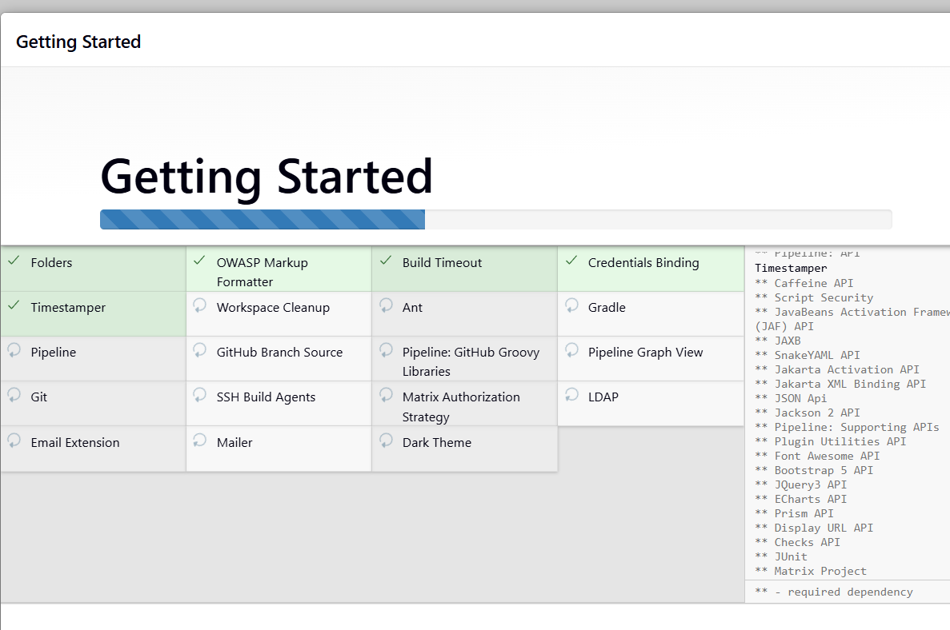
- Now we can securely login into the Jenkins finally.
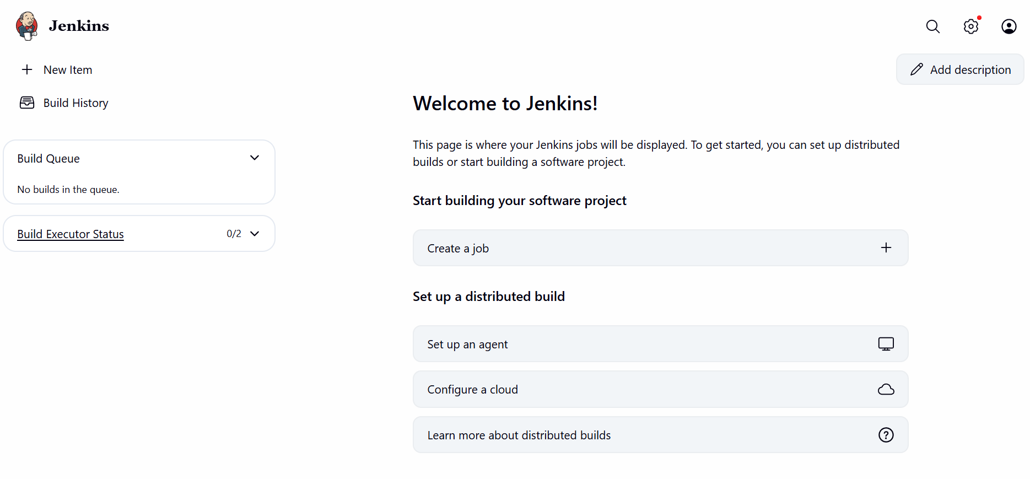

Step 10: Let’s verify if the initial password is automatically deleted from the deployment location.
Deployment location is: var/lib/Jenkins

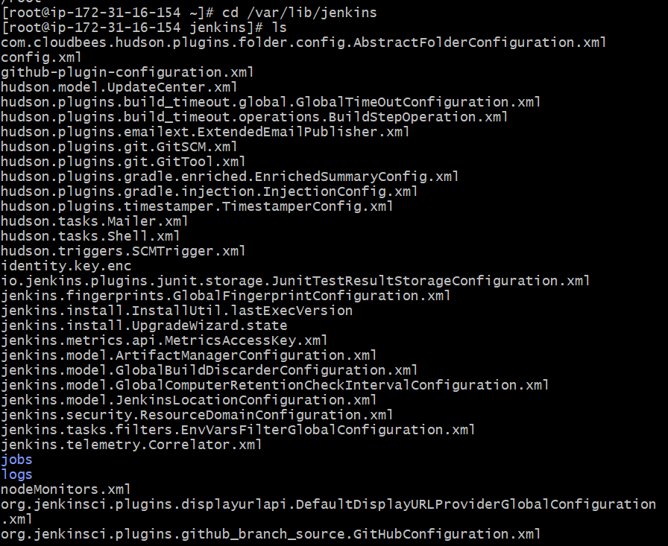

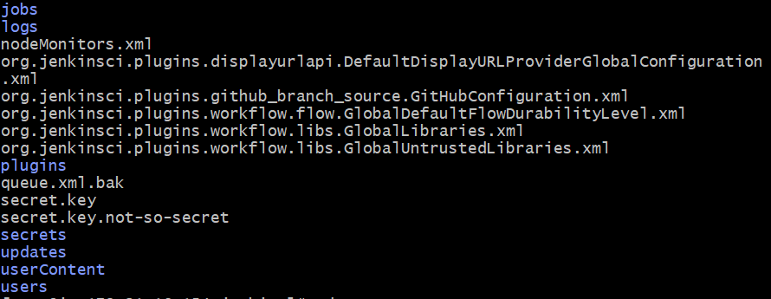

Step 11: Now change directory to cd secrets to verify if the intial password is avaialble!!

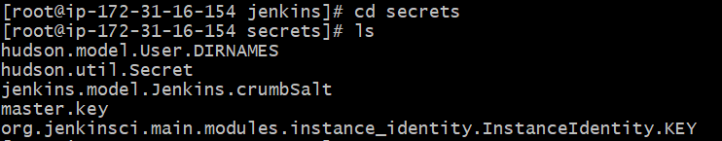

Success- The initial password is automatically removed.

Step 12: We need to create users and provide access accordingly to users to the Jenkins GUI jobs.

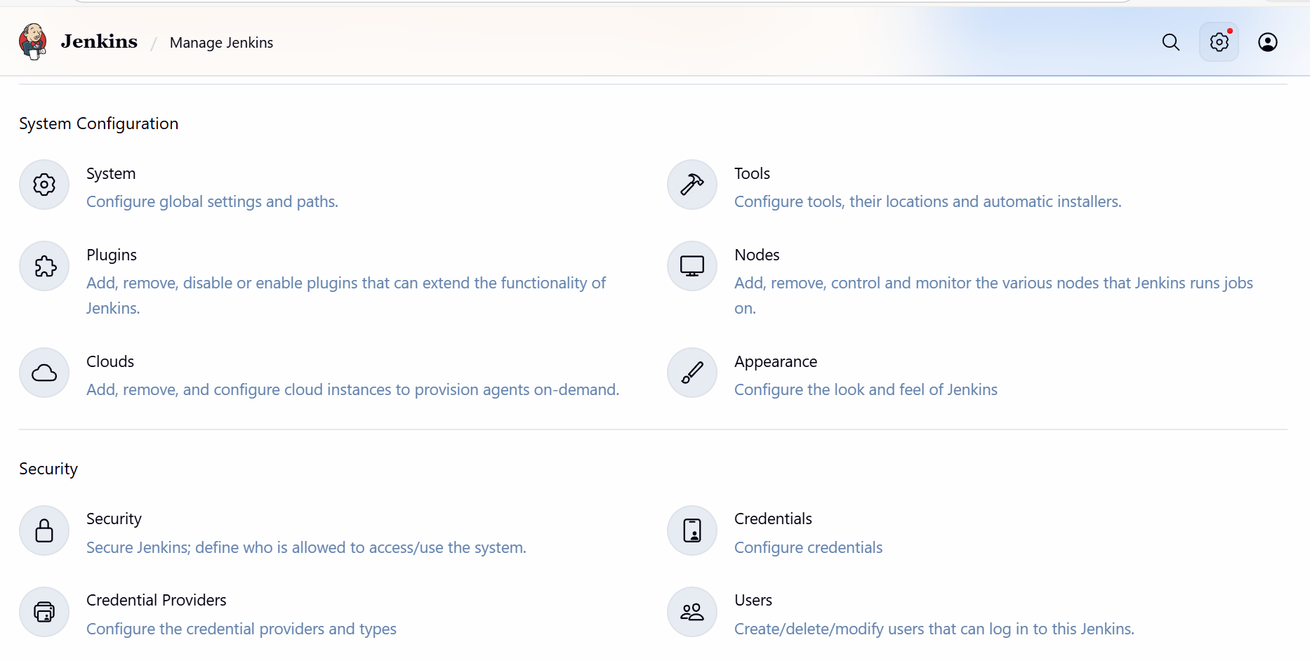

Step 13: Click on the “Create User”

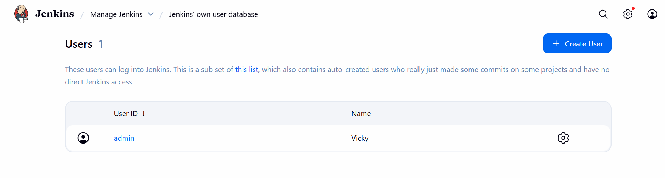

Step 14: Create our 1st user- Devops

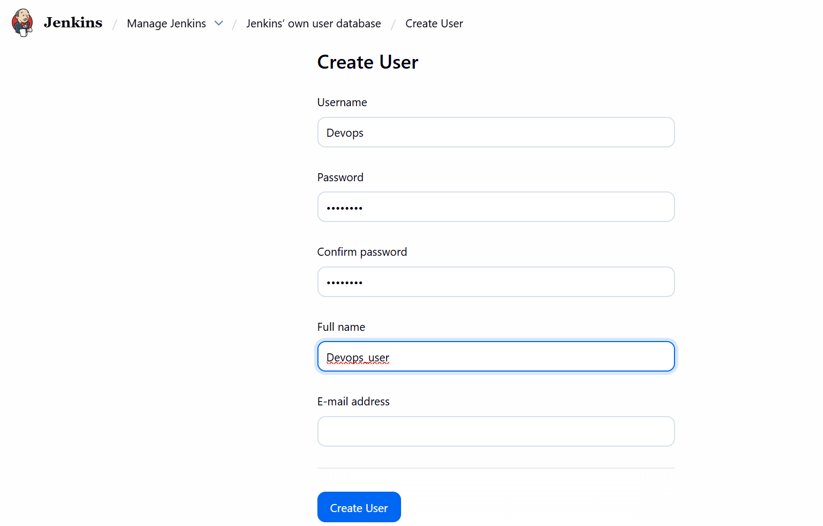
- Devops user created.

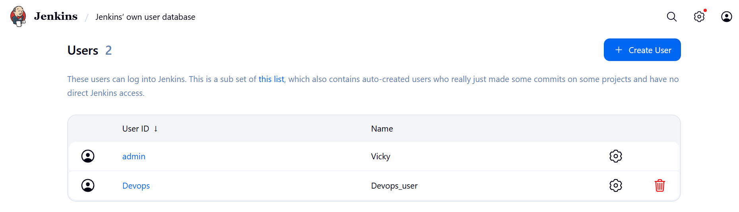

Step 15: Create our 2nd user

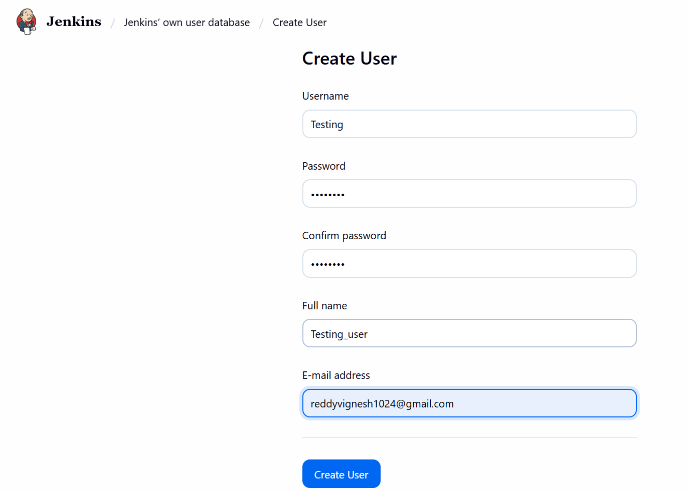
- Created our 2nd user- Testing successfully.

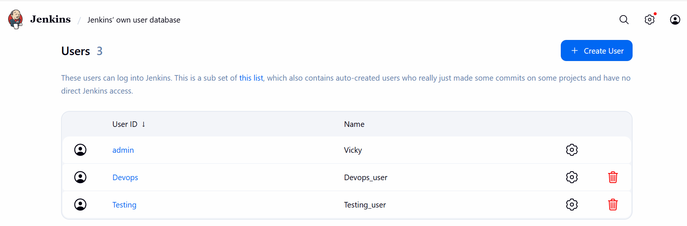

Step 16: Now, we shall Install plugins to provide limited access to Devops and Testing.

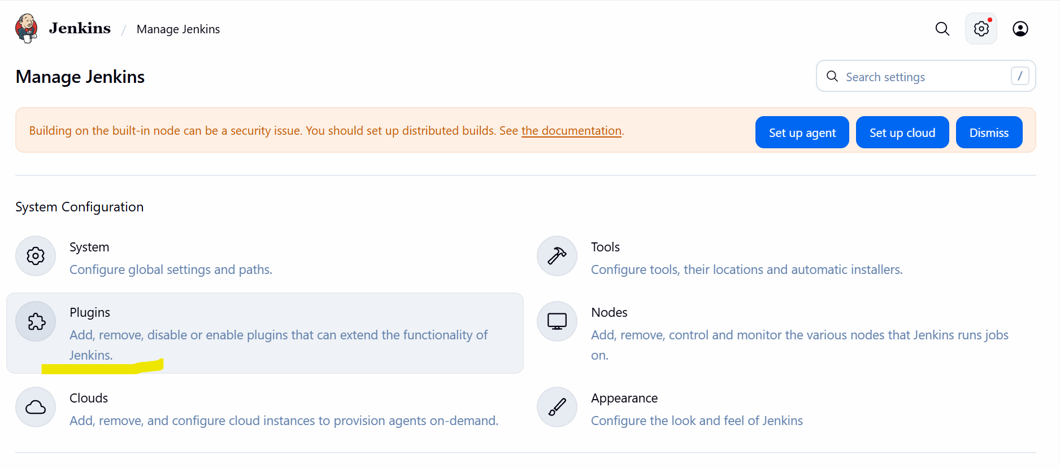

- Search for- Role-based Authorization Strategy and Install.

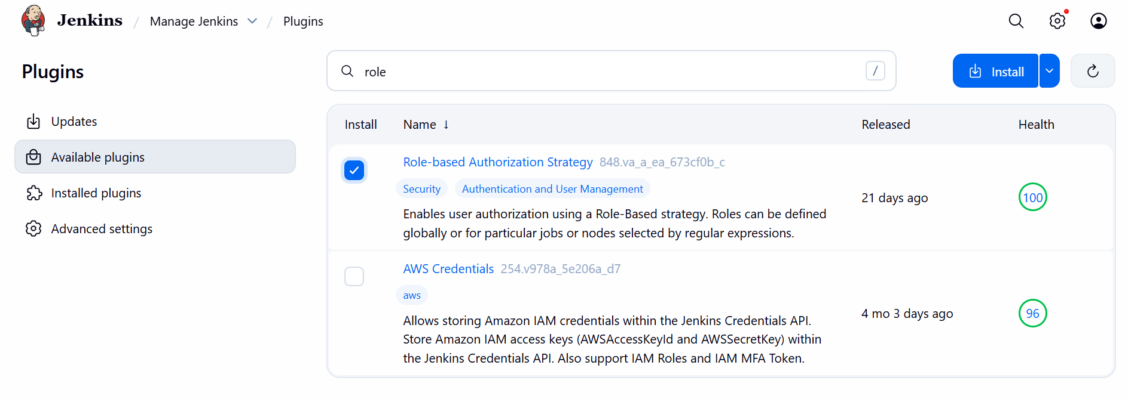

- Always, go back to the top page, do not restart Jenkins.

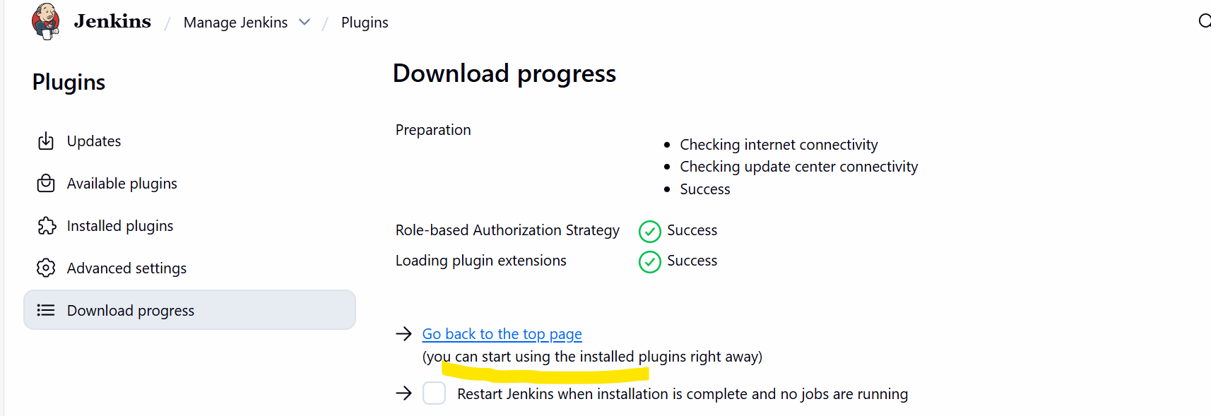

- Verified by going back to the plugins and search under Installed Plugins

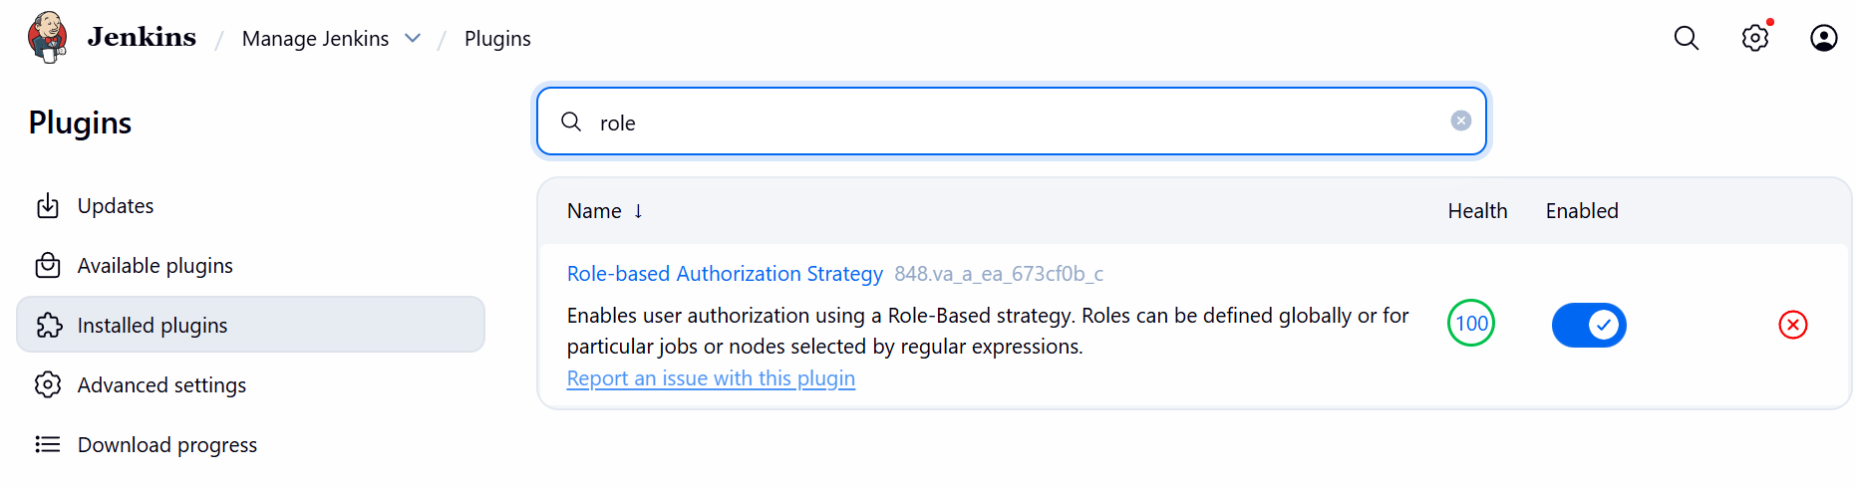

Step 17: Navigate to Manage Jenkins select Security Authorization and select Project-based Matrix Authorization Strategy.

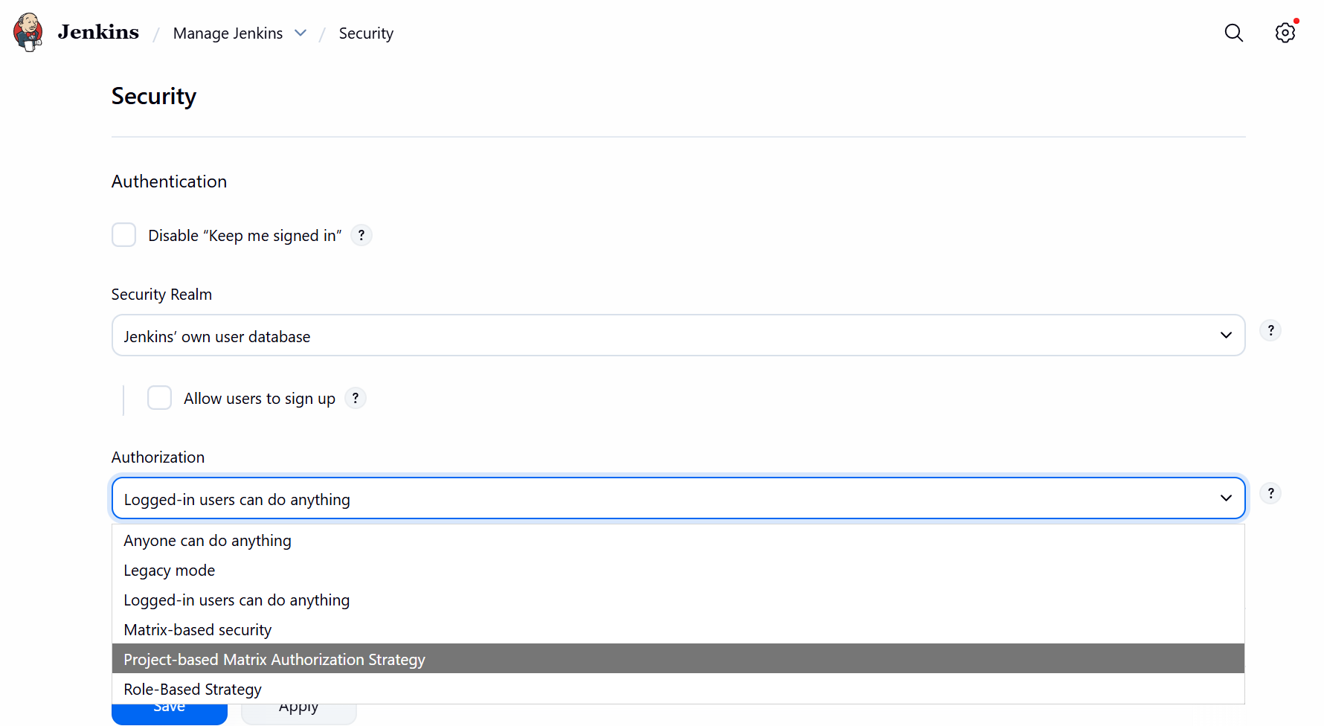
Step 18: Now, we added 2 users to the Project-based Matrix Authorization Strategy and provided just access to “Job” except delete option.

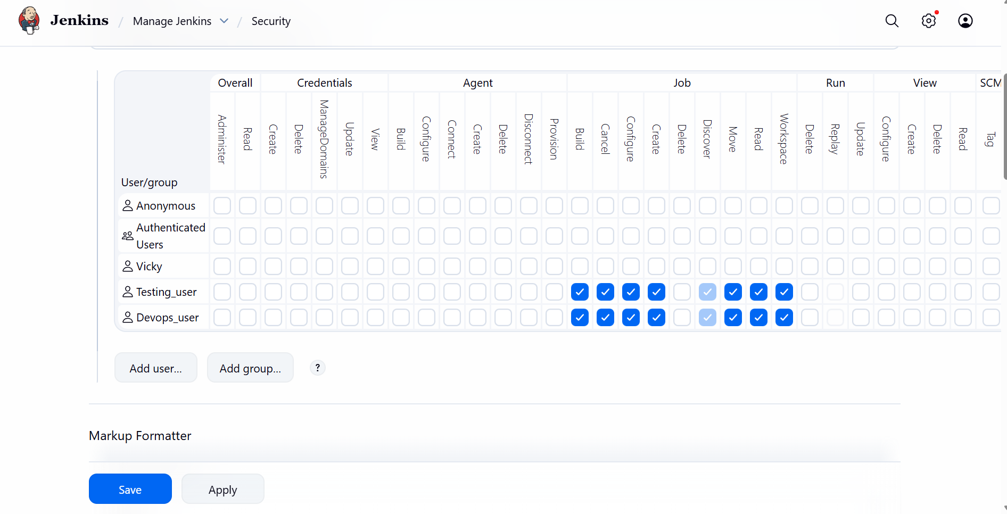

Conclusion: Always provide permissions correctly to ensure, we do not need to have a error at some stage that, someone working at a wrong place might result in Jenkins server issue.

Maven Compilation- Compile the source codes and create a package for us.

- Official page for Maven will provide us the recent package and tar.gz.
- Paste the copied tar.gz in Jenkins server.
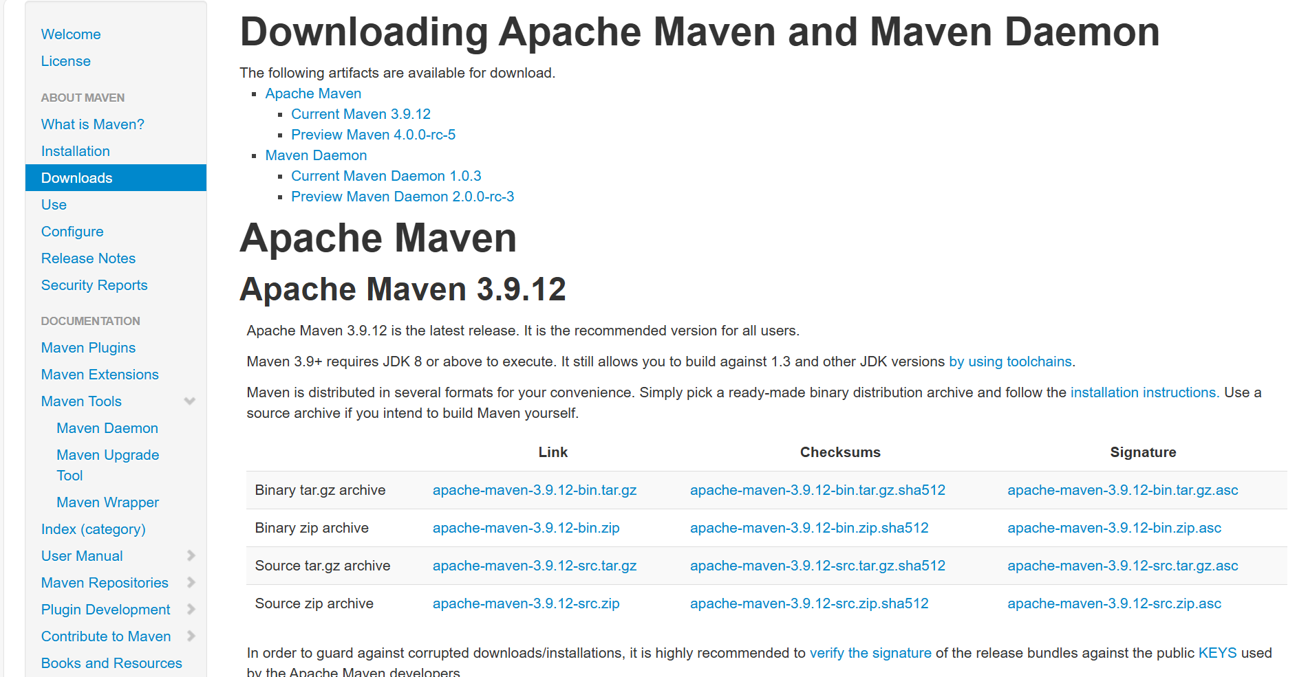

Step 19: Install the Maven in Jenkins server.

wget https://dlcdn.apache.org/maven/maven-3/3.9.12/binaries/apache-maven-3.9.12-bin.tar.gz

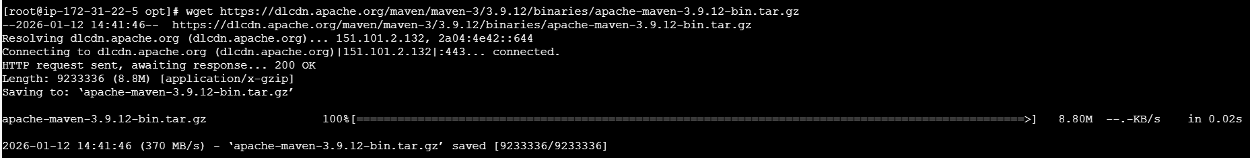

- Extract the package using below command.

tar xvf apache-maven-3.9.12-bin.tar.gz

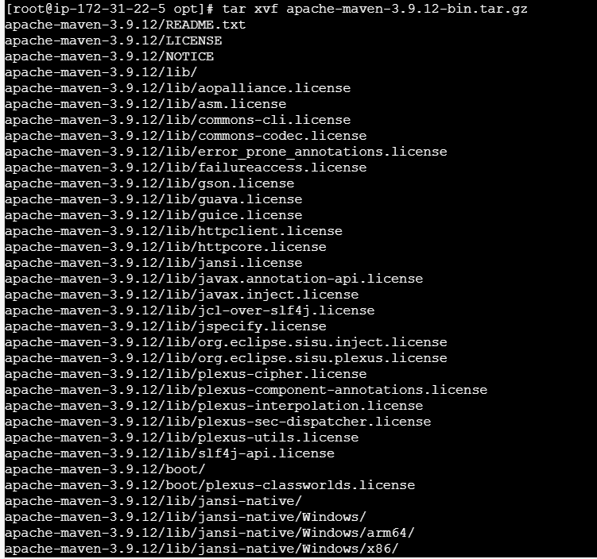

- Cd apache-maven-3.9.12/
- ll

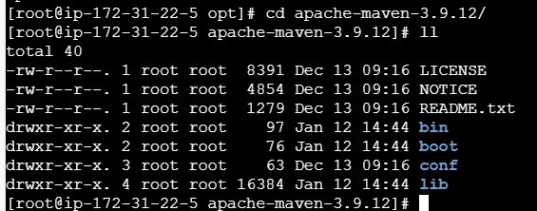

- cd bin/
- pwd
- copy the path and paste in the Jenkins GUI under Manage Jenkins tool

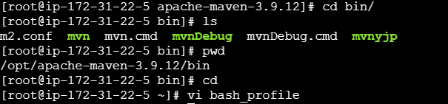

- Using vi .bash_profile, we can make sure to verify if the maven is available via mvn –version.
- This is used to globally verify from any directory or anywhere from Jenkins server.
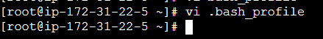

MVN_HOME=/opt/apache-maven-3.9.12
PATH=$PATH:$HOME/bin:$MVN_HOME/bin

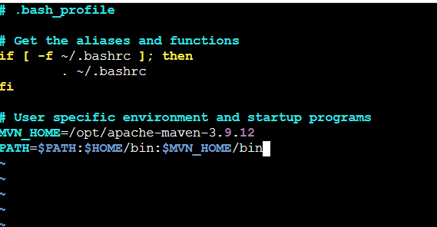

Restart the file using command- source ~/.bash_profile
Verify using command- mvn –version
Success- Its working as expected. Always, make sure to add vi .bash_profile for any file, so that it is globally used version.

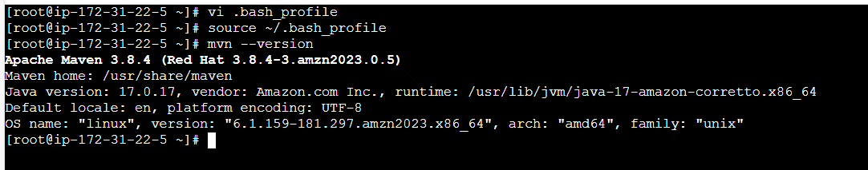

Step 20: Navigate back to Jenkins server and install Maven plugin
- Installed.

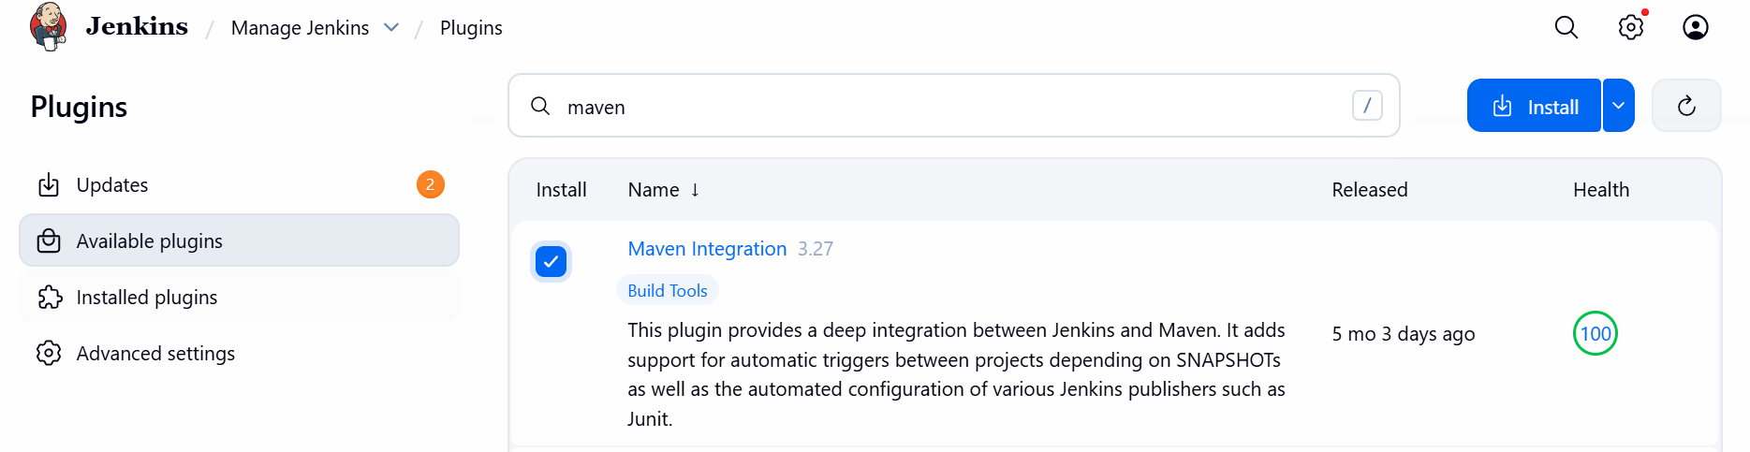

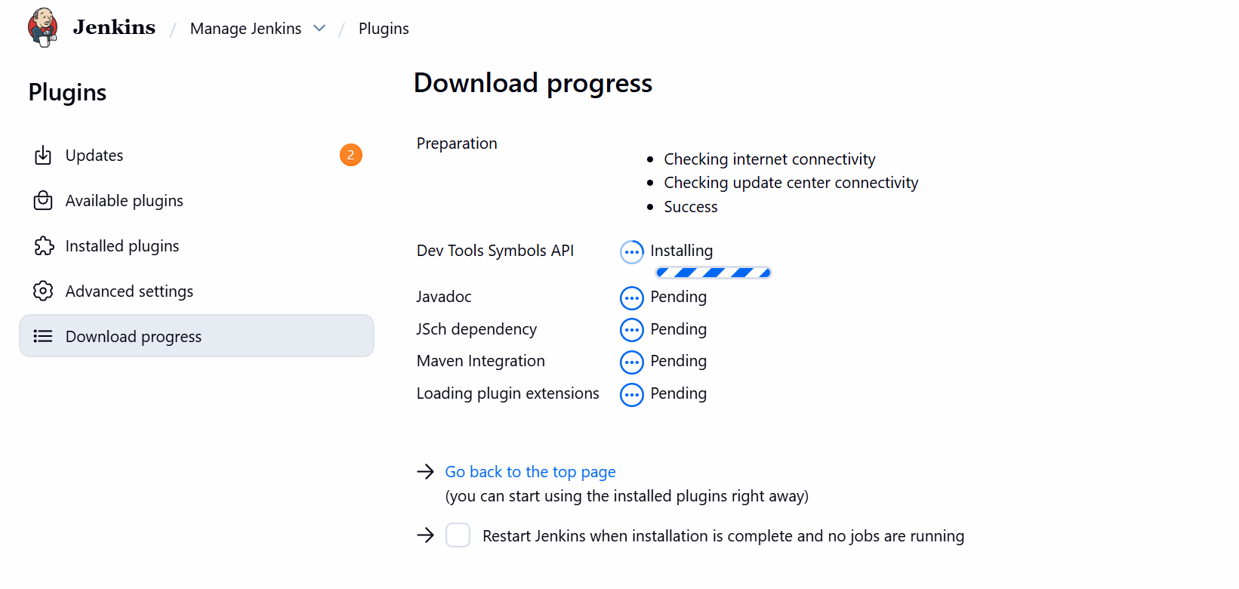

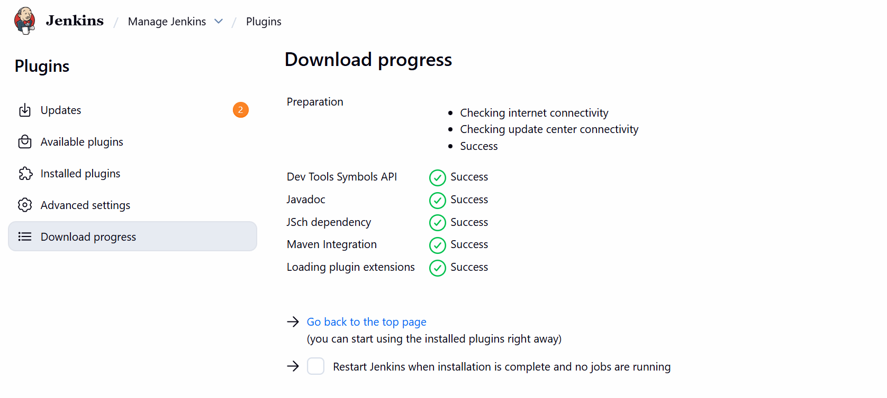
Step 21: As we copied the path earlier from Jenkins server under bin/ directory.
- Paste below in Tool.
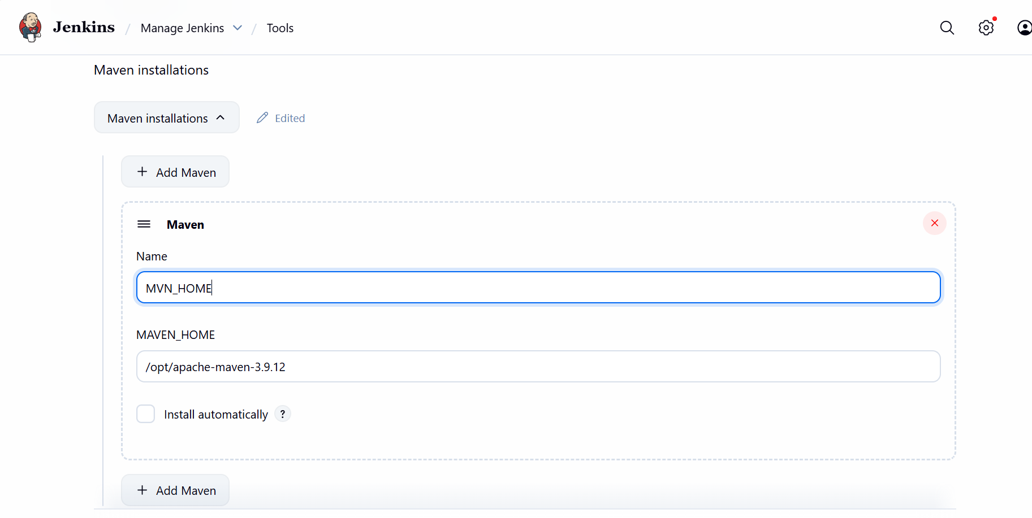

Step 22: Navigate to Job created- Jenkins-04 and under Build steps Invoke top-level Maven targets
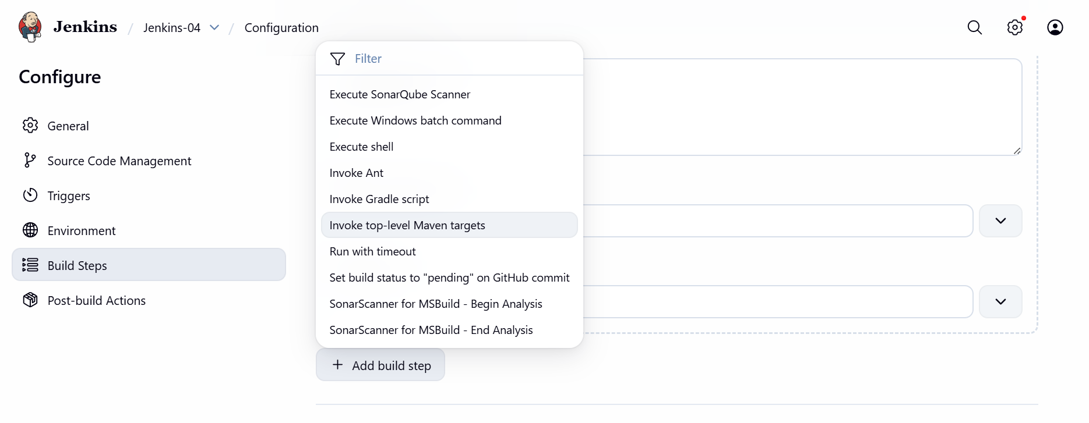
- Update Maven Home which we created in Jenkins server under vi ./bash_profile.
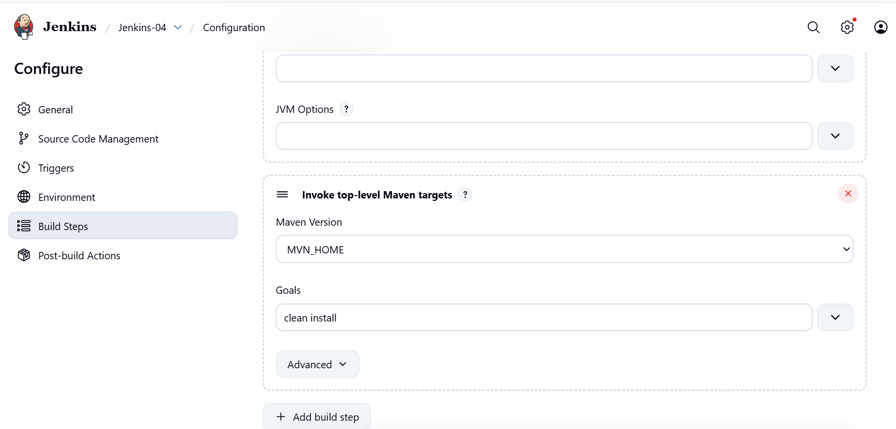

Step 22: Create a new job- Simple_customer_app paramterized

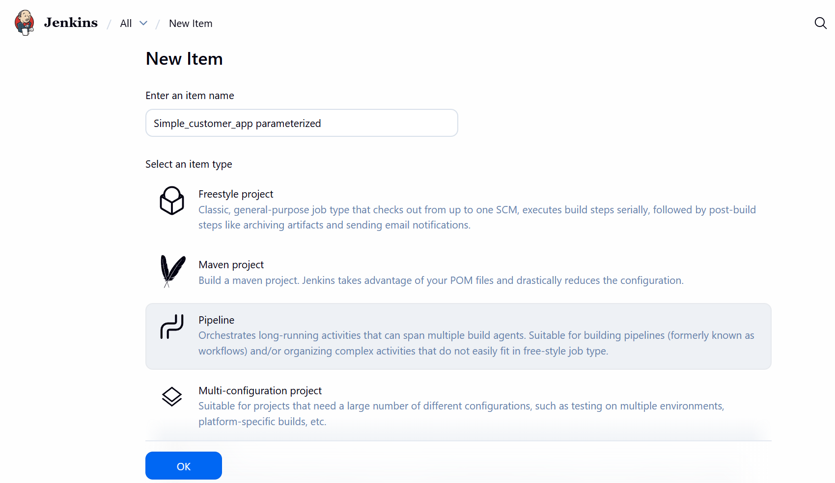

- Configure the job and add a script to run the Declarative pipeline.
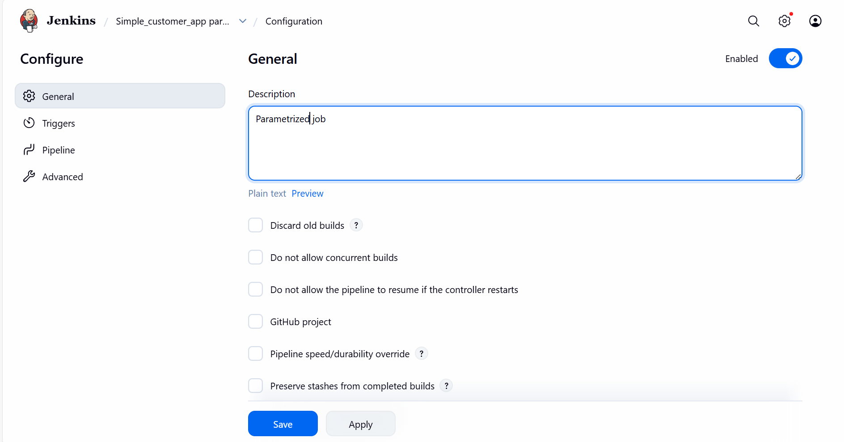
- Tick mark the job is Parameterized
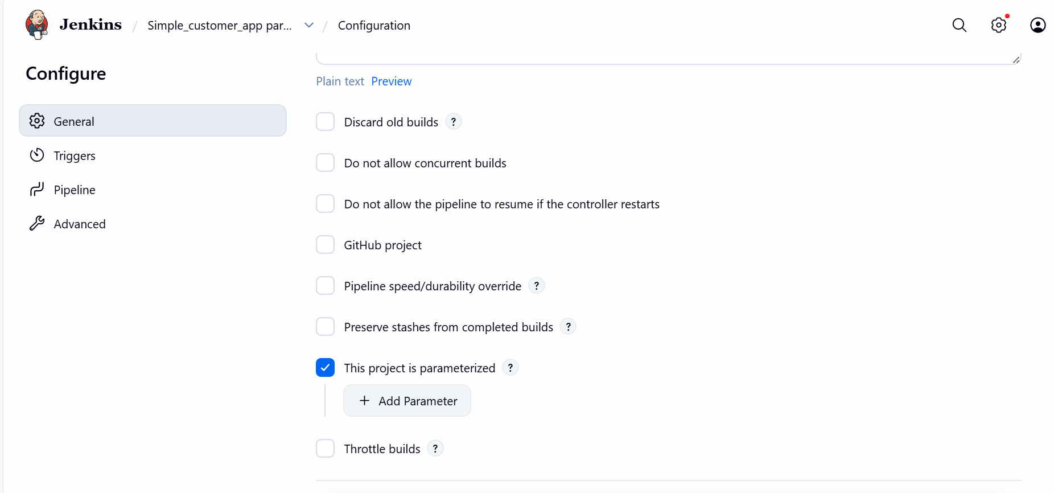

- Add a parameter- Choice Parameter
  - Name- ENV
  - Choices- dev, qa
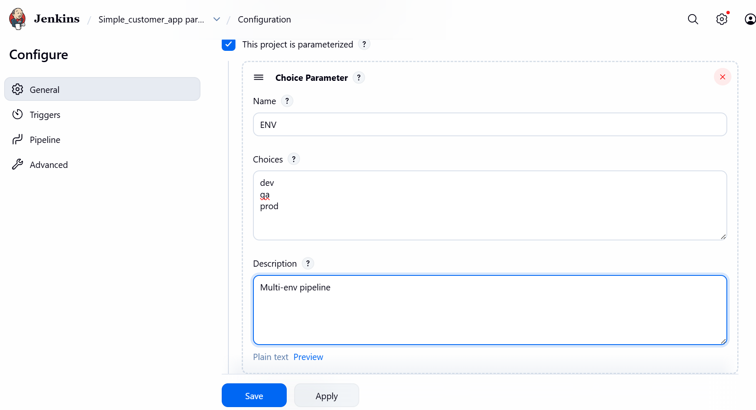
- Pipeline built with requirements and save
Note:
- We need to create a repo named- SimpleCustomerApp as per task expectation.
- Next step is to fork with a repo in GitHub. I forked with https://github.com/betawins/hiring-app.git
- Now, my Repo will be https://github.com/saivicky123/SimpleCustomerApp
- I shall paste this repo link my Declarative pipeline.

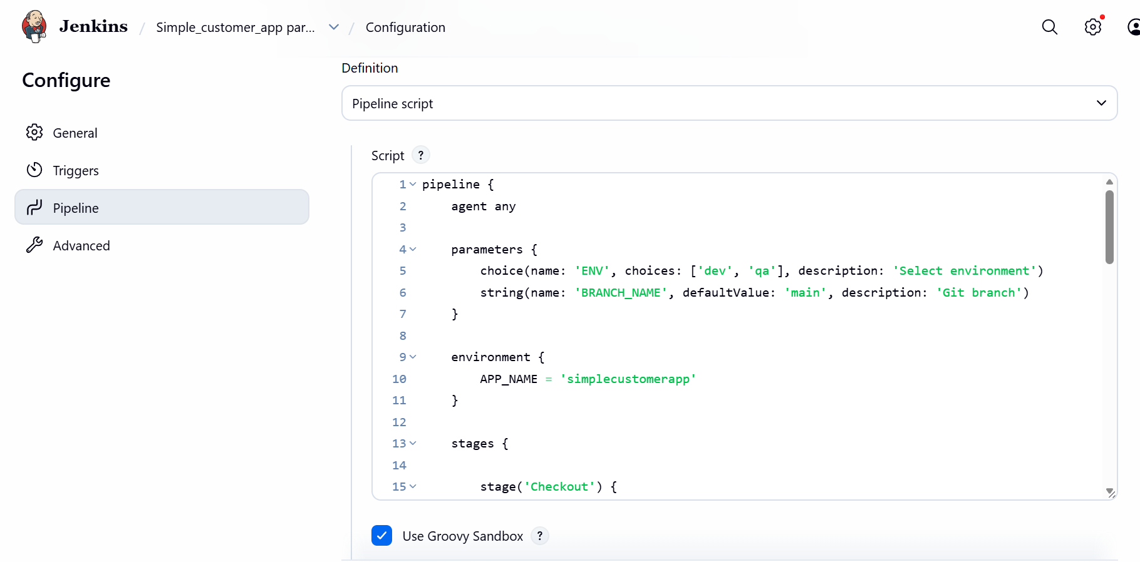

Step 23: Build Now with all configurations configured.
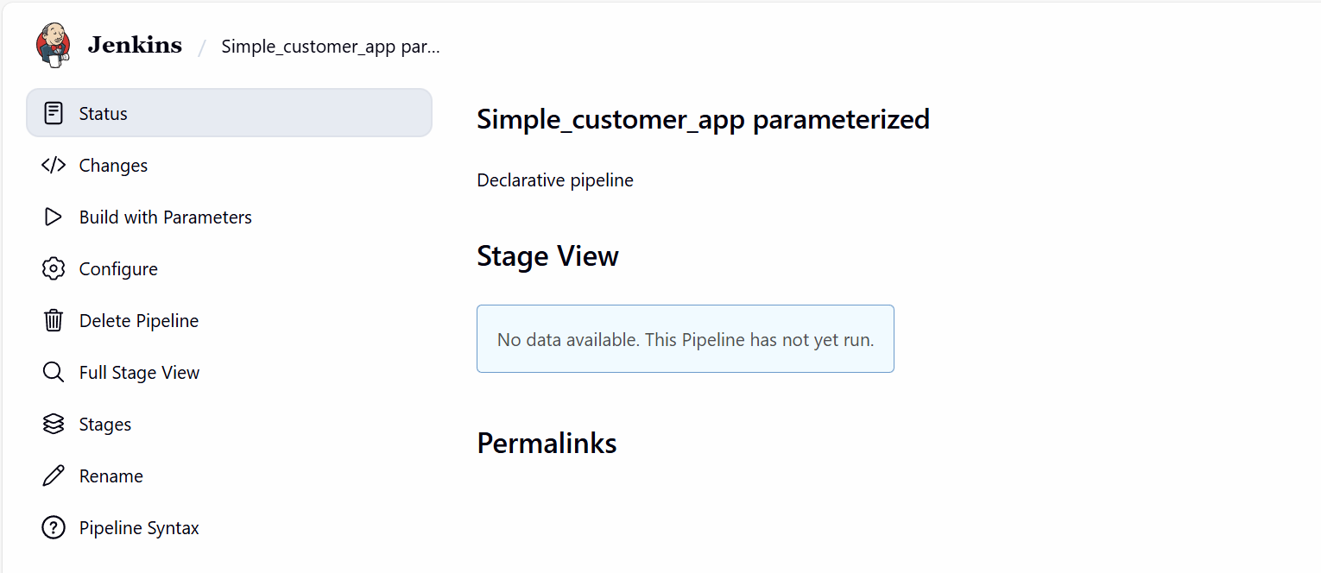

- Select dev environment.
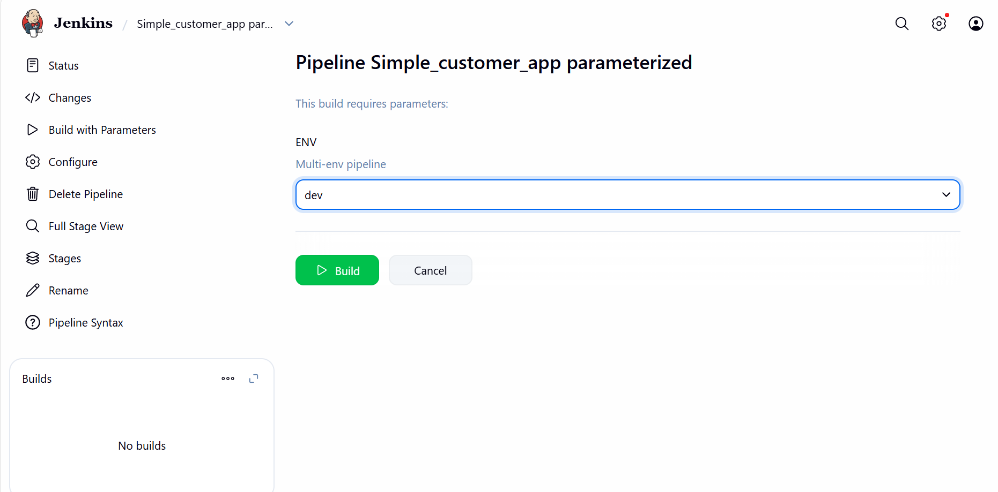

Step 24: Build Now and verify if job is passing
Success.
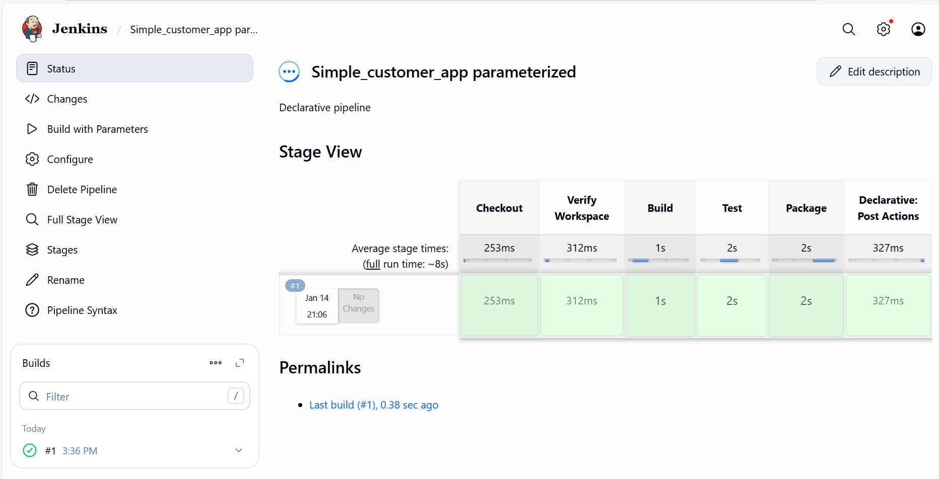
- Console output attached
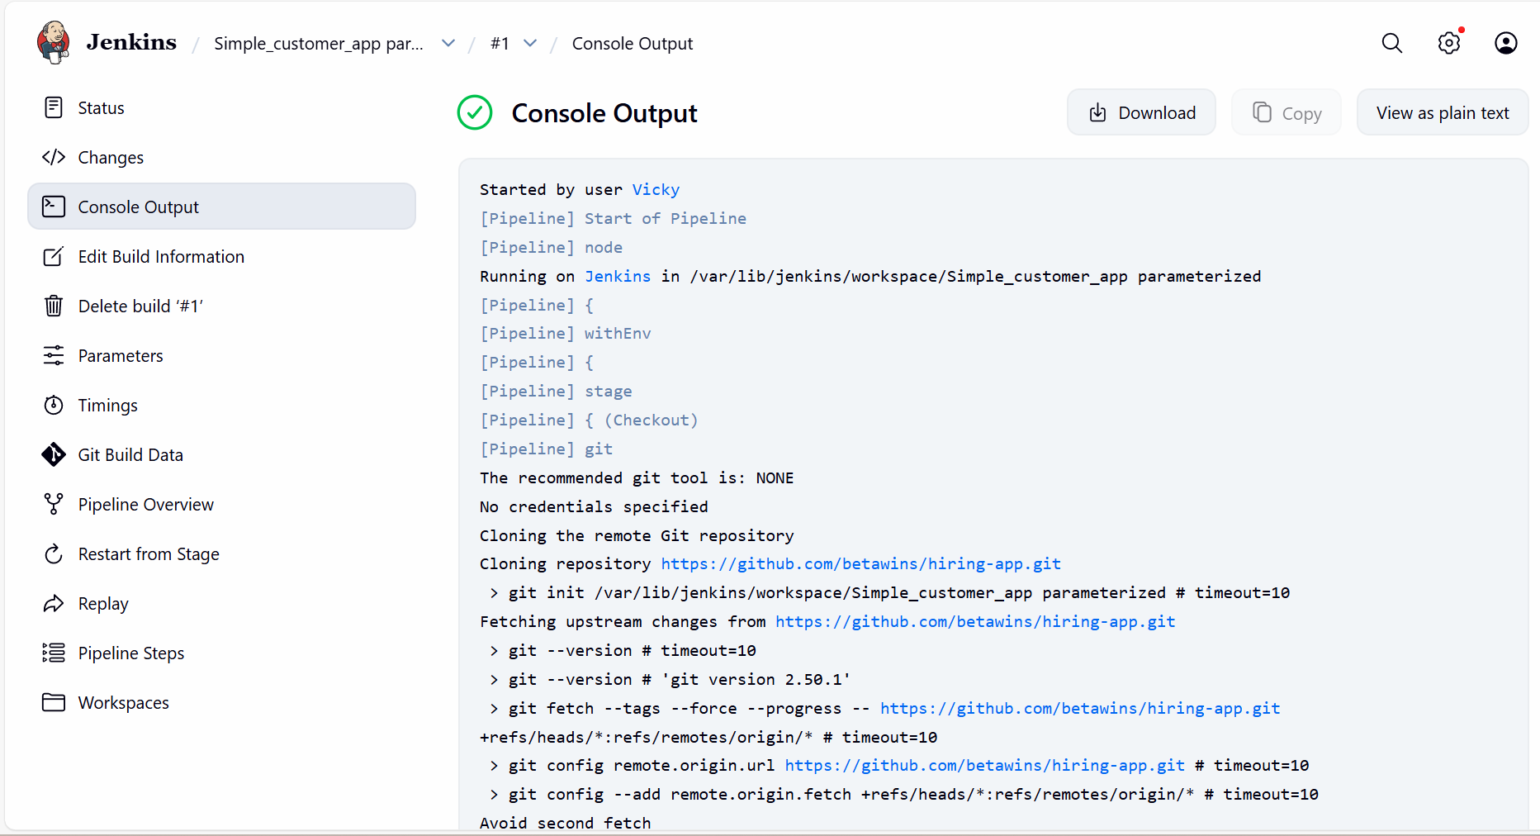

Conclusion:
This task demonstrates the creation of a real-world Jenkins Declarative Parameterized Pipeline. The pipeline automates code checkout, build, testing, and packaging, and successfully generates a JAR file using Maven.

Pipeline attached below.

pipeline {
agent any

parameters {
choice(name: 'ENV', choices: ['dev', 'qa'], description: 'Select environment')
string(name: 'BRANCH_NAME', defaultValue: 'main', description: 'Git branch')
}

environment {
APP_NAME = 'SimpleCustomerApp'
}

stages {

stage('Checkout') {
steps {
git branch: "${params.BRANCH_NAME}",
url: 'https://github.com/saivicky123/SimpleCustomerApp.git'
}
}

stage('Build') {
steps {
sh 'mvn clean compile'
}
}

stage('Test') {
steps {
sh 'mvn test'
}
}

stage('Package') {
steps {
sh 'mvn package'
}
}
}

post {
success {
slackSend(
color: 'good',
message: "Vicky | ${env.JOB_NAME} - #${env.BUILD_NUMBER} Success (<${env.BUILD_URL}|Open>)",
tokenCredentialId: 'Slack'
)
}

failure {
slackSend(
color: 'danger',
message: "Vicky | ${env.JOB_NAME} - #${env.BUILD_NUMBER} Failed (<${env.BUILD_URL}|Open>)",
tokenCredentialId: 'Slack'
)
}
}
}

